**Supplementary Requirement Release 2 I4**

1. DF-In -Data Flow In

**Scope:**

* UC 2.02 Access Footage Archive
* UC 2.03 Detect Overparking

**Requirements:**

* The data flow mechanism must ensure the seamless and accurate integration of sequential image data, spot occupancy labels (occupied or vacant), and timestamps into the "Access Footage Archive" feature.
* The system shall ensure that spot occupancy statuses (free/occupied) and associated timestamps utilized within the "Detect Overparking" feature remain consistent and synchronized with the corresponding data employed across other application modules, validating accuracy and synchronization.

**Conditions to Apply:** After the respective join points

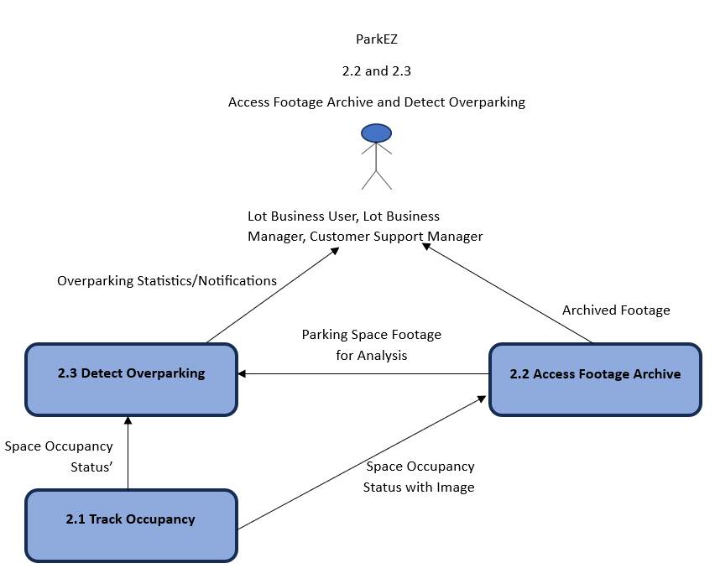

2. EN ET - Entitlements External

**Scope:**

* UC. 2.02 Access Footage Archive
* UC 2.03 Detect Overparking

**Requirements:**

* The system shall limit access to the "Access Footage Archive" feature to users with Lot Business Manager entitlement.
* The system shall limit access to the "Detect Overparking" feature to users possessing the entitlements of Customer Support Manager and Lot Business Manager.

**Conditions to Apply:** After the respective join points.

3. EN IN - Entitlements Internal

**Scope:**

* UC.2.02 Access Footage Archive
* UC.2.03 Detect Overparking

**Requirements:**

* Limit access to the footage archive feature to users assigned to roles (customer support managers and business lot managers) associated with business lots.
* Verify that access to the ‘Detect Overparking’ feature is exclusively granted to Customer Support Managers and Lot Business Managers, while being hidden from logged-out users, Advertising Users/Managers, and Accountants.

**Conditions to Apply:** After the respective join points.

4. CL- Calculations

**Scope:**

* UC. 2.03 Detect Overparking

**Requirements:**

* The system shall accurately identify and label parking spaces that are occupied, using a sequence of images taken over time.
* For each occupied spot, the system shall calculate the total time the spot has been occupied by subtracting the timestamp of the first image where the spot is labeled as occupied from the timestamp of the most recent image where the spot is still occupied.
* This calculated duration shall be converted into hours (e.g., 1.6 hours) and programmatically reported by ParkEz for verification against manual calculations.

**Conditions to Apply:** After the respective join points.

5. ER- Enrichment

**Scope:**

* UC. 2.03 Detect Overparking

**Requirements:**

* The system shall enhance the parking occupancy data by calculating and integrating the duration of parking occupancy. It will use the timestamps from continuous occupancy detection to determine the exact duration a spot has been occupied.
* For each occupied spot, the system shall calculate the duration by finding the time difference between the latest image showing the spot occupied and the immediately preceding image where the spot was continuously marked as occupied.
* The duration will be converted into hours and presented in a format that is easy for the users to understand (e.g., 1.6 hours), enriching the primary data set with a time-based perspective of occupancy.

**Conditions to Apply:** After the respective join points.

6. CN - Connectivity

**Scope:**

* UC. 2.02 Access Footage Archive
* UC. 2.03 Detect Overparking

**Requirements:**

* Ensure the system can queue overparking incidents and footage archive access requests during periods of intermittent connectivity and process them once connectivity is restored.

**Conditions to Apply:** After the respective join points.

7. CS - Client Setup

**Scope:**

* UC. 2.02 Access Footage Archive
* UC. 2.03 Detect Overparking

**Requirements:**

* Confirm that client-side configurations allow for proper initiation and handling of the overparking detection and footage archive access processes.
* Verify that users' devices meet the minimum requirements to ensure the integrity and performance of the overparking detection feature.

**Conditions to Apply:** After the respective join points.